DECLARATION

We, MUHAMMED NIYAD, ADIL SAFVAN. EGRAHIM BASIL, FARAS CK bearing the Register No MXAXBCA041,
MXAXBCA025, MXAXBCA005, MXAXBCA007 studying in the final semester of Bachelor of Computer application at Malabar College of Arts and Science Moodadi North, hereby declare that this project work entitled “PIXEL PACT” which is being submitted by them in the partial fulfilment for the award of the degree of Bachelor of Computer Science, from University of Calicut, Thenjippalam is an authentic record of me carried out during the academic year 2025-2026, under the guidance of Mrs. PRIYANKA.K.P, H.O.D.Department of Computer Science, MCAS Moodadi North.

(Signature of the candidates)
NAME: MUHAMMED NIYAD Reg.no: MXAXBCA041 ADIL SAFVAN MXAXBCA025
EBRAHIM BASIL MXAXBCA005
MUHAMMED FARAS CK MXAXBCA007

I certified that the declaration made above by the candidate is true

(Signature of the guide)
MRS.PRIYANKA.K.P
H.O.D. in Computer Science

ABSTRACT
In the evolving landscape of digital art, the need for a decentralized, trust-driven platform for art commissioning has become essential. The proposed system is a blockchain-powered digital art collaboration and marketplace application that connects users and artists in a secure and dynamic environment. Users can generate or upload image concepts and open them for bidding, where multiple verified artists can propose their own price and turnaround time.
The system ensures transparency, artist credibility, and secure payment using blockchain-backed smart contracts. Users can also bypass bidding by directly requesting a preferred artist for personalized projects. All commissioned artworks, transactions, ratings, and ownership are recorded immutably on the blockchain, ensuring protection from fraud, plagiarism, and disputes. This solution combines automation, personalization, and trust, creating a next-generation platform for creative collaboration between users and digital artists.

LIST OF FIGURES

LIST OF TABLES

LIST OF ABBREVIATIONS

1

INTRODUCTION

INTRODUCTION
In today’s rapidly evolving digital world, the demand for unique and innovative digital art is continuously increasing, yet artists often face challenges in showcasing their work, securing commissions, and protecting their intellectual property. PixelPact emerges as a cutting-edge solution to address these challenges by providing a blockchain-powered collaborative digital art platform that seamlessly integrates creative expression with secure and transparent transactions. The platform enables artists to generate or upload art concepts and opens opportunities for other artists to bid on collaborative projects or for clients to commission work directly. By leveraging blockchain technology, PixelPact ensures that every transaction, ownership record, and creative contribution is immutable, fostering trust and accountability among users. Additionally, the system incorporates smart contracts that automate agreements, guaranteeing fair compensation and adherence to project terms without manual intervention. The mobile application further enhances accessibility, allowing artists and clients to interact, preview, and manage projects anytime and anywhere. PixelPact also integrates AI-driven tools to provide suggestions, enhancements, and previews, thus supporting creativity and experimentation while maintaining the originality of the artwork. By combining secure technology, collaborative features, and an intuitive interface, PixelPact not only empowers artists to monetize their creativity effectively but also cultivates a vibrant digital art community, bridging the gap between artistic talent and market opportunities in a transparent, efficient, and innovative manner.

PURPOSE OF THE PROJECT
The primary purpose of the PixelPact project is to create a secure, transparent, and decentralized digital marketplace that bridges the gap between art enthusiasts and digital artists. Traditional online art platforms often lack credibility, fair pricing mechanisms, and protection against plagiarism or payment fraud. PixelPact addresses these limitations by leveraging blockchain technology to ensure trustless transactions, verifiable ownership, and immutable art records. Through features like AI-generated concept creation, artist bidding, direct commissions, and blockchain-backed smart contracts, the system empowers both users and artists to collaborate confidently in a transparent ecosystem. Ultimately, the project aims to establish a next-generation digital art marketplace that promotes authenticity, fairness, and innovation in the creative economy.

SCOPE OF THE PROJECT
PixelPact aims to revolutionize the digital art ecosystem by providing a secure, collaborative, and blockchain-powered platform for artists and art enthusiasts. The project facilitates seamless interaction between creators and clients through features such as art concept generation, bidding for commissions, and direct commissioning, all while ensuring transparency and trust via smart contracts. It also incorporates a mobile application, making art collaboration and marketplace access more flexible and user-friendly. The scope of PixelPact extends to supporting secure transactions, preserving intellectual property rights, and offering AI-assisted suggestions for art enhancement. Furthermore, it provides a structured environment for both amateur and professional artists to showcase their talent, receive feedback, and monetize their work, thereby bridging the gap between artistic creativity and market opportunities.

2
Literature Review

In recent years, digital art marketplaces have rapidly evolved, yet most centralized platforms still face challenges such as copyright infringement, lack of transparency, and unreliable payment mechanisms. Researchers have highlighted that blockchain technology can provide effective solutions by enabling secure, immutable transactions and verified ownership of digital assets [1]. According to studies on decentralized marketplaces, smart contracts play a crucial role in establishing trust between buyers and sellers by automating agreements without intermediaries [2]. Furthermore, integrating Artificial Intelligence (AI) into creative platforms enhances personalization and innovation, allowing users to generate or refine digital art concepts efficiently [3]. Prior works on NFT-based systems and decentralized art networks emphasize that blockchain not only ensures authenticity and provenance but also empowers artists with fair compensation and global exposure [4]. Building upon these findings, PixelPact adopts blockchain-backed smart contracts and AI tools to create a transparent, user-centered ecosystem that enhances collaboration, credibility, and creative freedom in digital artistry.

References

1. Nakamoto, S. (2008). Bitcoin: A Peer-to-Peer Electronic Cash System.

2. Buterin, V. (2014). A Next-Generation Smart Contract and Decentralized Application Platform. Ethereum White Paper.

3. Goodfellow, I., Bengio, Y., & Courville, A. (2016). Deep Learning. MIT Press.

4. Dowling, M. (2022). NFTs and the Future of Digital Art: Blockchain-Based Provenance and Ownership. Journal of Business Research, 142, 758–769.

3

SYSTEM ANALYSIS

SYSTEM ANALYSIS

INTRODUTION
System Analysis is a crucial phase in the software development life cycle (SDLC) that focuses on understanding, examining, and defining the functional and non-functional requirements of a system. In this phase, the existing system (if any) is studied to identify its limitations, inefficiencies, and challenges, followed by designing a new system that effectively addresses those issues. For PixelPact, system analysis involves a detailed examination of how digital art platforms currently operate, the problems faced by users and artists—such as lack of transparency, insecure transactions, and limited communication—and how a blockchain-based solution can overcome these barriers. This stage helps to clearly define user roles, system modules, data flow, and the interaction between components to ensure the final design aligns with real-world needs. Through careful analysis, PixelPact aims to build a robust, secure, and user-friendly platform that enhances trust, creativity, and collaboration between digital artists and clients.

STUDY PHASE

The PixelPact project focuses on thoroughly analyzing the current scenario of digital art platforms, identifying their shortcomings, and formulating a structured solution using blockchain technology. This phase helps in understanding the overall workflow, system requirements, user expectations, and how the proposed system can overcome the existing challenges efficiently and securely.

EXISTING SYSTEM
Most current digital art platforms primarily function as portfolio showcases or direct commission websites. These systems lack transparency in transactions, pricing clarity, and proper verification of artist authenticity. Users often face issues like overpricing, delayed delivery, fraud, or plagiarism. There is no reliable mechanism to ensure that payments are secure or that the ownership of digital artworks is recorded and protected. Furthermore, communication between clients and artists is often fragmented, with no unified environment for collaboration or negotiation.

LIMITATIONS OF THE EXISTING SYSTEM
- Lack of trust and transparency between users and artists.
- No decentralized mechanism to verify authenticity or prevent art theft.
- Absence of a fair bidding process for commissioning digital artworks.
- Insecure payment gateways prone to disputes and scams.
- Limited options for artist-client interaction and feedback management.
No permanent record of transactions or ownership

PROPOSED SYSTEM
The PixelPact system introduces a blockchain-powered decentralized platform for digital art collaboration, buying, and selling. The new system ensures secure, transparent, and verifiable transactions using smart contracts. Users can post art concepts for bidding or directly commission artists of their choice. Each transaction, rating, and artwork ownership is recorded immutably on the blockchain to prevent fraud and copyright issues. The platform integrates features like AI-based image generation, artist verification, secure payments, real-time chat, and rating systems for both parties

OBJECTIVES OF THE DETAILED STUDY
- To analyze user requirements and system functionalities.
- To compare and evaluate existing systems and identify gaps.
- To design a structure that integrates blockchain for secure transactions.
- To establish modules for admin, user, and artist roles.
- To ensure scalability, reliability, and user-friendly operation.

Benefits of the Proposed System

Transparency: All transactions and bids are verifiable through blockchain.

Security: Payments and ownership records are tamper-proof.

Efficiency: Streamlined communication and bidding process.

Fairness: Artists receive fair compensation and recognition for their work.

Scalability: Can be expanded to support NFTs, global art trading, and advanced AI tools.

FEASIBILITY STUDY
A feasibility study is a preliminary investigation undertaken to determine and document a project's viability. The results of this study are used to decide whether to proceed with the project. If approved, it helps ascertain the likelihood of the project's success before actual development begins. It involves analyzing possible alternative solutions to a problem and recommending the most suitable one. The feasibility study provides a conceptual idea of the new system, specifying what tasks will be automated, what inputs and outputs are required, and which processes remain manual. During this phase, all alternatives are discussed and evaluated based on technical, operational, and economic aspects. A cost-benefit analysis is often carried out to compare the cost of implementation with the expected benefits, which are usually more qualitative than quantitative.

A feasibility study is necessary when:

- The current system no longer meets requirements.
- Technological advancements make the current system obsolete.
- The organization is expanding and needs better workload management.
- Users or customers express dissatisfaction with performance or quality.
- Competitors gain an advantage through improved digital systems

Thus, the feasibility study helps determine whether the proposed PixelPact system can be developed with available resources, time, and technology.

TECHNICAL FEASIBILITY

The PixelPact system is technically feasible as it is built using modern and reliable technologies. The front end is developed using HTML, CSS, Bootstrap, and JavaScript, ensuring an interactive and responsive user interface. The backend employs Python Django and Dart (Flutter) for handling web and mobile platforms respectively, providing a scalable and efficient framework for managing multiple users and operations.

The database system MySQL ensures smooth data handling, while blockchain integration provides secure, immutable transaction storage. Tools like Android Studio and PyCharm support the development and testing processes efficiently. Given the hardware requirements (Intel i3 or above, 4GB RAM, 512GB storage), the system can run smoothly on commonly available setups, confirming that the proposed solution is technically implementable.

OPERATIONAL FEASIBILITY
Operational feasibility determines how effectively the new system will function once implemented. PixelPact is designed with a user-friendly interface to ensure easy accessibility for both artists and clients. Features like AI-generated art concepts, bidding, real-time chat, payment management, and blockchain verification are straightforward and practical for users.

The system benefits all stakeholders:

- Users can securely commission artworks, post concepts, and choose artists through transparent bidding.
- Artists gain exposure, fair payment, and protection against plagiarism.
- Admins can efficiently manage users, verify artists, and monitor activities.

Training requirements are minimal, as the platform follows standard web and mobile usability practices. Thus, operational adoption and day-to-day functionality are both highly feasible.

ECONOMIC FEASIBILITY

Economic feasibility assesses whether the project is financially viable. Since PixelPact primarily uses open-source tools and technologies such as Python Django, MySQL, and Flutter, the cost of development is significantly reduced. The main expenses include hosting, blockchain integration, and initial development efforts.

In the long term, the system offers high economic benefits through secure and automated art transactions, reducing the need for intermediaries and minimizing fraud losses. The project’s value increases as it can generate revenue through commission fees, premium memberships, and featured artist listings. Hence, the economic feasibility is strong, ensuring a high return on investment (ROI).

TIME FEASIBILITY

Time feasibility examines whether the project can be completed within a reasonable timeframe. The PixelPact project follows a structured development approach divided into phases—analysis, design, development, testing, and deployment. With efficient task allocation and use of modern frameworks, the system can be completed within the planned schedule without compromising quality.

The use of ready-made libraries, blockchain APIs, and cloud hosting services further speeds up implementation. Therefore, PixelPact is time-feasible and achievable within a standard academic or professional development duration.

CONCLUSION

The feasibility analysis of PixelPact demonstrates that the project is technically, operationally, economically, and temporally feasible. With the combination of blockchain technology, secure architecture, and user-oriented design, the system is practical to implement and promises significant benefits for digital artists, clients, and administrators. This confirms that PixelPact is a sustainable and valuable solution for revolutionizing the digital art marketplace.

MODULE DISCRIPTION

Admin

- Login
- View User
- Verify Artist
- View Complaints and Send Reply
- View Art Ratings
- Block/Unblock Artist

User

- Register
- Login
- Update Profile
- Image Generate and Post
- View Request and Verify
- Chat with Artist
- View Artist and Send Request
- Payment
- Send Complaint and View Reply
- Send Rating
- View Work and Send Request
- Post Image Concepts for Bidding

Artist

- Register
- Login
- Update Profile
- View Posts and Send Requests
- View Request Status
- Chat with User
- Manage Works
- Manage Skilled Area
- View Request from User and Verify
- View Payment Status
- View My Rating
- View Work Request and Verify
- Place Bids on Commission Requests

2.7.PROJECT SHEDULING

For the successful completion of every project there must be detailed scheduling. The software development has different participating steps. First of all, We have done the requirement analysis phase. For this visit different sites, make an interaction with students for identifying different problems they are faced during their career selection. Then, We discuss these collected requirements with our project guide. After collecting the requirements, a detailed study of preliminary investigation is done. It includes six major questions
- What is being done?
- How it is being done?

- Done a problem exist?

- If a problem exists how severe it is?

- How frequently does it occur?
- What is main reason for that problem?
At the end of analysis phase the requirement is divided into modules. The document is created, which includes data flow diagrams, ER diagrams etc. As next step the actual development of the system takes place. The design representations are translated into codes. Documentation of codes is done by providing an explanations of how procedures are used. Documentation is essential to test the program and carry on maintenance once the application has been installed. As next step testing is done. After a system has been developed it is very important to check if it fulfils the customer requirements. Implementation of the system means putting up system on user’s side. Like any system there is an aging process. Therefore the system requires periodic maintenance for software or hardware.

4

SYSTEM REQUIREMENT SPECIFICATION

SYSTEM REQUIREMENT SPECIFICATION

INTRODUCTION
System Analysis is a crucial phase in the software development life cycle (SDLC) that focuses on understanding, examining, and defining the functional and non-functional requirements of a system. In this phase, the existing system (if any) is studied to identify its limitations, inefficiencies, and challenges, followed by designing a new system that effectively addresses those issues. For PixelPact, system analysis involves a detailed examination of how digital art platforms currently operate, the problems faced by users and artists—such as lack of transparency, insecure transactions, and limited communication—and how a blockchain-based solution can overcome these barriers. This stage helps to clearly define user roles, system modules, data flow, and the interaction between components to ensure the final design aligns with real-world needs. Through careful analysis, PixelPact aims to build a robust, secure, and user-friendly platform that enhances trust, creativity, and collaboration between digital artists and clients.

SOFTWARE SPECIFICATION

One of the most difficult tasks in selecting software, once the system requirement is found out then we have to determine whether a particular software package fits for those system requirements. This section summarizes the application requirement

Software Component | Description / Purpose
Operating System | Windows 8 or above (for development and testing)
Backend Framework | Python Django – for handling logic, APIs, and database connectivity
Frontend Technologies | HTML5, CSS3, Bootstrap, JavaScript – for creating a responsive and user-friendly interface
Mobile Application Framework | Flutter (Dart) – for developing cross-platform mobile apps
Database Management System | MySQL – for secure and efficient data storage and retrieval
Integrated Development Environments (IDE) | PyCharm, Android Studio, or Visual Studio Code – for development and debugging
Web Server | Apache / Django Development Server
Version Control | Git / GitHub – for code versioning and team collaboration
Blockchain Integration Tools | Blockchain SDKs and APIs (for implementing smart contracts and secure transactions)
Browser Support | Google Chrome, Mozilla Firefox, or Microsoft Edge

HARDWARE SPECIFICATION
The PixelPact system requires minimal yet efficient hardware to ensure smooth operation and testing. The specifications are as follows

Hardware Component | Minimum Requirement | Recommended Requirement
Processor | Intel Core i3 or equivalent | Intel Core i5 or above
RAM | 4 GB | 8 GB or above
Hard Disk Space | 512 GB | 1 TB (SSD preferred)
Monitor | 15-inch display or larger | Full HD display for better UI testing
Input Devices | Standard Keyboard and Mouse | Wireless Keyboard and Mouse
Internet Connection | Basic broadband connection | High-speed broadband or fiber
Mobile Device (for testing) | Android 9.0+ or iOS 12+ | Latest Android/iOS device for optimal testing

TECHNOLOGY SPECIFICATION
The PixelPact platform integrates multiple technologies to ensure high performance, data security, and user satisfaction. The technology stack includes:

Technology | Purpose / Functionality
Blockchain Technology | Ensures secure, transparent, and immutable transaction records using smart contracts.
Python Django Framework | Manages the server-side logic, authentication, and API endpoints efficiently.
Flutter (Dart) | Enables development of cross-platform mobile applications with a single codebase.
MySQL Database | Provides reliable, relational data storage for user, artist, and transaction information.
HTML, CSS, Bootstrap, JavaScript | Used for developing the responsive web interface.
RESTful APIs | Facilitates communication between frontend, backend, and mobile app components.
AI Image Generation (Optional) | Allows users to generate concept images using built-in AI tools.
Smart Contracts (Blockchain) | Automates secure payments and contract verification between users and artists.
Git/GitHub | Used for source code management and collaboration during development.

5

DESIGN PHASE

INTRODUCTION

A software design is a meaningful engineering representation of some software product that is to be built. A design can be traced to the customer’s requirements and can be assessed for quality against predefined criteria.
During the design process the software requirements model is transformed into design models that describe the details of the data structures, system architecture, interface, and components. Each design product is reviewed for quality before moving to the next phase of software development
Design forms a blue print of the system and adds how the components relate to each other. The design phase proceeds accordingly to an ordinary sequence of steps, beginning with review and assignment of task and ending with package design. Design phase is the life cycle phase in which the detailed design of the system selected in the study phase is accomplished. A smooth transition from the study phase to design is necessary because the design phase continues the activities in the earlier phase. The first step in the design phase is to design the database and then input and output within predefined guidelines.

ARCHITECTURAL DESIGN
Architecture is an overall structure of a system. Architecture takes into consideration the overall working of the system. Large system can be decomposed into sub-systems that provide some related set of services. The initial design process of identifying these sub- systems and establishing a framework for sub- system control and communication is called architecture design.
Architecture design usually comes before detailed system specification. Architecture decomposition is necessary to structure and organize the specification. There is no generally accepted process depends on application knowledge and on the skill and intuition of the system architect.

DATA FLOW DIAGRAM

Data Flow Diagram is the graphical description of the system’s data and how the processes transform the data. Data Flow diagram depicts information flow, and the transform that are applied as data move from the input to output. It is the starting point of the design phase that functionally decomposes the requirement specifications down to the lowest level of details

Thus a DFD describes what data flows (logical) rather than how they are processed Unlike detailed flowchart, Data Flow Diagrams do no supply detailed description of the modules but graphically describes a system’s data and how the data interacts with the system. A DFD consists of a series of bubble joined bylines. The bubble represents data transformation and lines represent data flow in the system. So DFD is also called Bubble Chart

BASIC DFD SYMBOLS:
To Construct a Data Flow Diagram with the help of following symbols.

      - Arrow
      - Circles

      - Open End Box
      - Squares

ARROW
An arrow identifies the data flow in motion. It is a pipeline through which information is flown like the rectangle in the Flow Chart.
Data may flow a source to a processor and from a data store or process. An arrow line depicts the flow, with the arrowhead pointing in the direction of flow.

CIRCLE

Circle stands for process that converts the data into information

A process represents transformation where incoming data flow is changed into outgoing flows.

RECTANGLE

A Rectangle defines a source or destination of system data. A source is a person or a part of organization, which enters or receives information from the system but is considered to be outside the context of the data flow model.

OPEN END BOX

An Open End Box represents a data store, data at rest or temporary reposition of data

A graphical picture of the logical steps and sequence involved in a procedure or a program is called a flow chart. Unlike detailed flow chart, Data Flow Diagram does not supply detailed description of the modules but graphically describes a system’s data how the data interact with the system.

SIX RULES FOR CONSIDERING DATA FLOW DIAGRAM

- Arrows should not cross each other
- Squares, circles and Data Store must have names

- Decomposed data flow squares and circles can have the same names.
- Choose meaningful names for data flow

- Draw all data flows around the outside of the diagram.
- Control information such as record count, password and validation Requirement is not relevant to Data Flow Diagram.

DIFFERENT LEVELS OF DATA FLOW DIAGRAMS:
A dataflow diagram as a diagram that depicts data source, data sinks, data storage and processes performed on data as nodes, and logical flow of data as links between the nodes. Generally DFD are used as a design notation to represent architectural design and top level design specification.
DFD represent the system in hierarchical manner with the one top level and many lower level diagrams with each representing separate parts of the system. Since diagrammatic representations are easier to interpret as compared to the technical descriptions, the non-technical users can also understand the system details clearly.

LEVEL 0

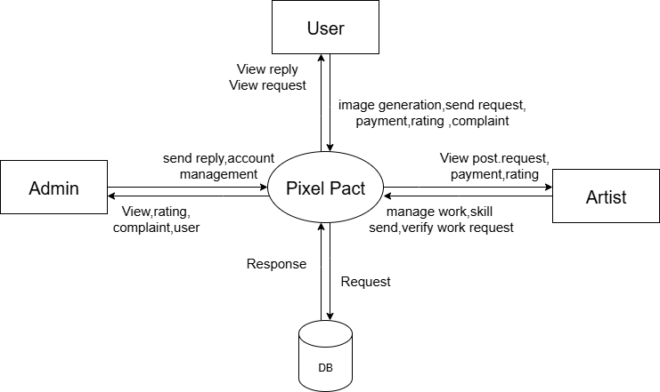

Fig:

LEVEL 1

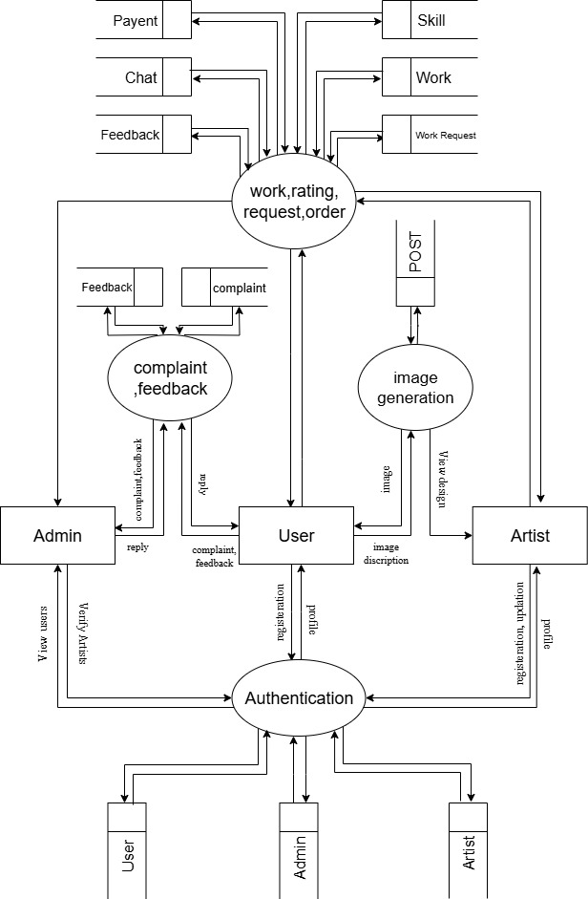

Fig: 4

LEVEL 1.1

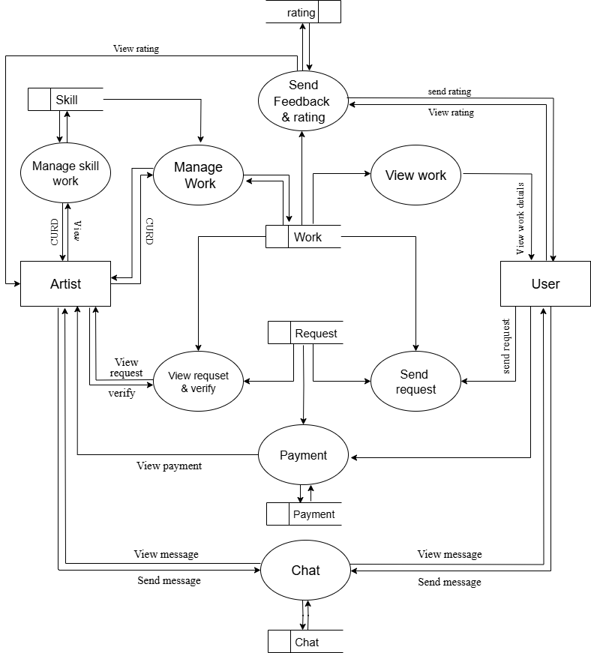

Fig:

LEVEL 1.2

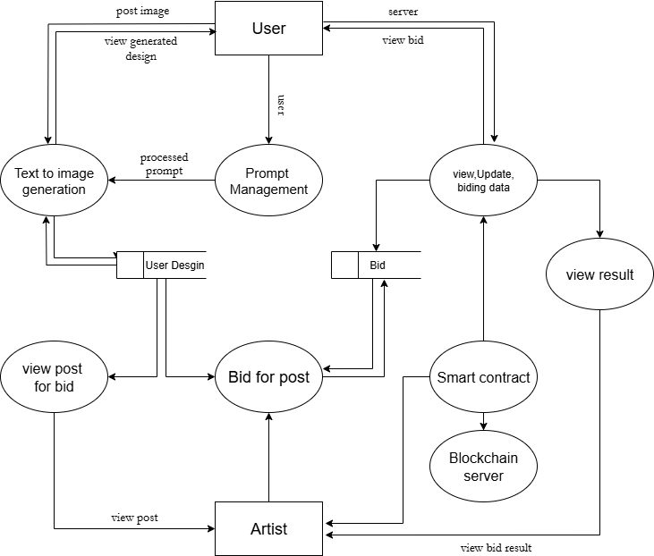

Fig

USE CASE DIAGRAM

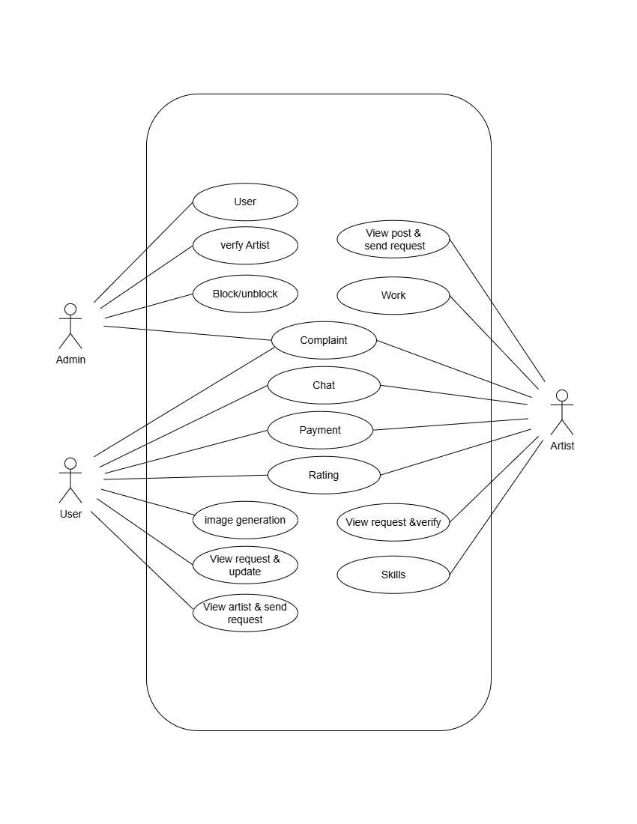

INPUT DESIGN

Input design is the process of converting the user-originated inputs to a computer based format. The design for handling input specifies how data are accepted for computer processing. Input design is a part of overall system design that needs careful attention and if includes specifying the means by which actions are taken.
A system user interacting through a workstation must be able to tell the system whether to accept input produce a report system design or end processing. The collection of input data is considered to be the most expensive part of the.
Since the inputs have to be planned in such a manner so as to get the relevant information extreme care is taken to obtain the information. If the data going into the system is incorrect then processing and outputs will magnify these errors.
The major activities carried out are

- Collection of needed data from the source.

- Conversion of data into computer application form.
- Verification of converted data.
- Checking data for accuracy.
The goal of designing input data is to make the automation as easy and free from errors as possible. For providing a good input design for the application easy data input and selection features are adopted. The input design requirements such as user friendliness, consistent format and interactive dialogue for giving the right message and help the user at right time are also considered also considered for the development of this project.

The following are the input of the system:

OUTPUT DESIGN
The output design is done so that the result of processing could be committed to the user and to provide a hard copy of these results and evaluations for later consultations. Effective output design will improve the clarity and performance of outputs. Output design phase of the system is concerned with the convergence of information’s to the end user- friendly manner. The output design should be efficient, intelligible so that system relationship with the end user is improved and there by enhancing the process of decision making.
There are three types of outputs

- External output.

- Internal output
- Operational output.

External Output

These outputs are prepared and given outside the organization. That is modified database.
Internal Output

These outputs are prepared exclusively for the people inside the organization. Operational Output
These outputs are used purely within the members of computer department itself. The output us the primary purpose of any system. The output design is discussed before other aspects of the design because the output is based on the client point of view. The following are the major output screens used for web portal for public services:

DATABASE DESIGN

Database design runs in parallel with the application design. As we collect information about what is to be done, we will obviously collect information about what data needs to be entered, stored, message and printed on reports. One of the main tasks in building a new system is determining the contents and structure of the database. The type of retrieval and recording required by the user and availability of inputs determine what data has to be stored. The database is a collection of related data
A comprehensive database should contain all the information necessary to manage the enterprise. Database can be implemented directly using file management program or a database management system. The objectives in establishing a database can be summarized as:
- Eliminate redundant data as much as possible.
- Integrate data files.
- Incorporate changes easily and quickly.

- Lower the cost of storing and retrieving data.

- Improve accuracy, integrity and consistency.
- Data independence.

- Privacy and security.

The various steps involved in database design are given below:

Organizing the data
As we gather the data, we will organize it into tables and begin to work out its connections. Our first goal is to identify the tables and the columns within the tables.

Identify the key
The next step in database design is to identify the key that is used as a primary key. A primary key is a column, which uniquely identifies a row in a table. Uniqueness is the key property of a primary key, so we have to choose it carefully. Then identify the foreign keys that are used. A foreign key is a key that is a column in a table, which acts as a primary key for another table. So after identifying the primary keys and the foreign keys, go to the next step of database design.
SQL
SQL is characterized as a free, fast, reliable open source relational database. It does lack some sophistication and facilities, but it has an active development team and, as it goes from release to release, more capabilities are added. At certain times there will be a trade- off between speed and capabilities, and the SQL teams intend to keep their database engine fast and reliable. It has a good feature set.
SQL is a multithreaded, multi-user, SQL Database Management System (DBMS) with more than six million installations.

NORMALISATION
Data structuring is refined through the process called normalization. The basic objective of normalization is to reduce the data redundancy, which means that information is stored only once. There are several normal forms, they are

FIRST NORMAL FORM
A relation is said to be in first normal form if and only if all the attribute values are atomic. In the First normal form;
      - All the key attributes are defined.

      - There are no repeating groups in the table. In other words, each row/column intersection can contain one and only one not a set of values
      - All the attributes are dependent on the primary key.

SECOND NORMAL FORM
To be in second normal form a table must be in first normal form and no attribute of the table should be functionally dependent on any part of the primary key
A table is in second normal form if:
        - It is in 1 NF

        - It include no PARTIAL DEPENENCIES; that is no attribute is dependent on a portion of the primary key
THIRD NORMAL FORM

To be in third normal form a table must be in second normal form and no attribute of the table should be transitively functionally dependent on the primary key.
          - It is in 2NF
          - It contains no transitive dependencies.

TABLE DESIGN & DESCRIPTION

User Table
Field Name | Data Type | Size | Constraints | Description
ID | INT | 11 | PRIMARY KEY | Unique identifier of each user
LOGIN | INT | 11 | FOREGIN KEY | Login details
NAME | VARCHAR | 50 | NOT NULL | Name of user
DOB | DATE | - | NOT NULL | Date of birth
PLACE | VARCHAR | 100 | NOT NULL | City/town of the user
POST | VARCHAR | 100 | NULL | Post office name
PIN | CHAR | 6 | NOT NULL | Pin code
GENDER | VARCHAR | 10 | NOT NULL | Gender of the user
PHONE_NO | BIG INT | 15 | NOT NULL | User’s phone number
EMAIL | VARCHAR | 100 | UNIQUE | User’s email address
IMAGE | VARCHAR | 250 | NULL | Artwork image

Complaint
Field Name | Data Type | Size | Constraints | Description
Id | INT | 11 | PRIMARY KEY | Unique identifier for each complaint
USER_ID | INT | 11 | FOREGIN KEY → Users.id
  Refers to the user who made the complaint.
ARTIST_ID | INT | 11 | FOREGIN KEY → Artists.id | Refers to the artist against whom the complaint is made
COMPLAINT | TEXT | - | NOT NULL | Complaint  details
REPLAY | TEXT | - | NOT NULL | Replay of complaint
DATE | DATE TIME | - | NOT NULL | Date and time when the complaint was submitted.

Artist
Field Name | Data Type | Size | Constraints | Description
ID | INT | 11 | PRIMARY KEY | Unique identifier for each artist
LOGIN | INT | 11 | FOREGIN KEY | Login details
NAME | VARCHAR | 50 | NOT NULL | Name of artist
DOB | DATE | - | NOT NULL | Date of birth
PLACE | VARCHAR | 100 | NOT NULL | City/town of the artist
POST | VARCHAR | 100 | NULL | Post office name
PIN | CHAR | 6 | NOT NULL | Pin code
GENDER | VARCHAR | 10 | NOT NULL | Gender of the artist
PHONE_NO | BIG INT | 15 | NOT NULL | artist’s phone number
EMAIL | VARCHAR | 100 | UNIQUE | artists email address
IMAGE | VARCHAR | 250 | NULL | Artwork image

Feedback
Field Name | Data Type | Size | Constraints | Description
ID | INT | 11 | PRIMARY KEY | Unique identifier for each feedback.
USER_ID | INT | 11 | FOREGIN KEY | Refers to the user giving feedback.
ARTIST_ID | INT | 11 | FOREGIN KEY | Refers to the artist receiving the feedback.
FEEDBACK | TEXT | - | NOT NULL | feedback  details
RATING | DECIMAL | 2,1 | NOT NULL | Rating given by the user
DATE | DATE TIME | - | NOT NULL | Date and time when the complaint was feedback submitted

Skill Area
Field Name | Data Type | Size | Constraints | Description
ID | INT | 11 | PRIMARY KEY | Unique identifier for each skill entry.
ARTIST_ID | INT | 11 | FOREGIN KEY
  Refers to the artist who has the skill.
SKILL | VARCHAR | 100 | NOT NULL | Name of work
DETAILS | TEXT | - | NULL | Details of work
DATE | DATE TIME | - | NOT NULL | Date and time when the skill was added.

User design
Field Name | Data Type | Size | Constraints | Description
ID | INT | 11 | PK, Auto Increment | Unique identifier for each DESGIN.
USER_ID | INT | 11 | FOREGIN KEY | Username of the user (for login/identification).
DESIGN_GENERATED | VARCHAR | 250 | NOT NULL | Number of artworks/designs generated by the user.
MAX_AMOUNT | DECIMAL | 10,2 | NOT NULL | Maximum transaction/payment amount allowed for the user.
STATUS | VARCHAR | 10 | NOT NULL, | Current account status.
DATE | DATE TIME | — | NOT NULL | Date & time of account creation or record entry.

Work
Field Name | Data Type | Size | Constraints | Description
ID | INT | 11 | PK, Auto Increment | Unique identifier for each work record.
ARTIST | INT | 11 | FK → Artists.id | Refers to the artist who created the work.
WORK | VARCHAR | 100 | NOT NULL | Title/name of the artwork or project.
AMOUNT | DECIMAL | 10,2 | NOT NULL | Payment/price associated with the work.
DESCRIPTION | TEXT | — | NULL | Detailed description of the work
DATE | DATE TIME | — | NOT NULL | Date & time when the work was upload
SKILL_AREA | VARCHAR | 100 | NOT NULL | Skill category of the work

Request
Field Name | Data Type | Size | Constraints | Description
ID | INT | 11 | PK, Auto Increment | Unique identifier for each request.
USER | INT | 11 | FK → Users.id | Refers to the user who made the request.
WORK | INT | 11 | FK → Work.id | Refers to the requested work or artwork.
STATUS | VARCHAR | 10 | NOT NULL, | Current status of the request.
DATE | DATE TIME | — | NOT NULL | Date & time when the request was made.

CHAT
Field Name | Data Type | Size | Constraints | Description
ID | INT | 11 | PRIMARY KEY, AUTO INCREMENT | Unique identifier for each chat message.
FROM_ID | INT | 11 | FOREIGN KEY → Users.id / Artists.id | Sender of the message.
TO_ID | INT | 11 | FOREIGN KEY → Users.id / Artists.id | Receiver of the message.
MESSAGE | TEXT | — | NOT NULL | Content of the chat message.
STATUS | VARCHAR | 10 | NOT NULL | Status of the message.
DATE | DATE TIME | — | NOT NULL | Date and time when the message was sent.

PAYMENT
Field Name | Data Type | Size | Constraints | Description
ID | INT | 11 | PRIMARY KEY, AUTO INCREMENT | Unique identifier for each payment.
REQUEST_ID | INT | 11 | FOREIGN KEY → Request.id | Refers to the work request for which payment is made.
AMOUNT | DECIMAL | 10,2 | NOT NULL | Payment amount (up to 99999999.99).
STATUS | VARCHAR | 10 | NOT NULL | Current status of the payment.
DATE | DATE TIME | — | NOT NULL | Date and time when the payment was made.

DIAGRAM DESCRIPTION

A model is a collection of conceptual tools for describing data, data relationship, data semantics, and consistency constrains. The E-R data model is a high-level conceptual data model that provides the designers with a collection of conceptual tool for describing the structure of a database. The E-R model perceives the real world as consisting of basic objects, called entities, and relationship among these objects. It developed to facilitate the database description by allowing specification of schema that represents the overall logical structure of a database. An E-R diagram can overall logical structure of a database graphically. E-R diagrams are simple and clear. An E-R diagram consists of the following major components.

SYMBOL | MEANING
E | Entity Set
E | Weak Entity
R | Relationship Set
R | Identifying relationship for weak entity
A | Attribute
C | Key attribute
  R | Multivalued attribute
B  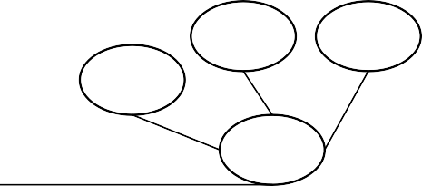  A  C | Composite attribute

 | Derived attribute
  E1 _{R} _{E2} | Total participation of E2 in R
 | One-to-one relationship
 | Many-to-one relationship
 | Many-to-many relationship
1.h | Cardinality limit
 | Role indicator

Table 4.4.1 ER Diagram And Description

ER DIAGRAM

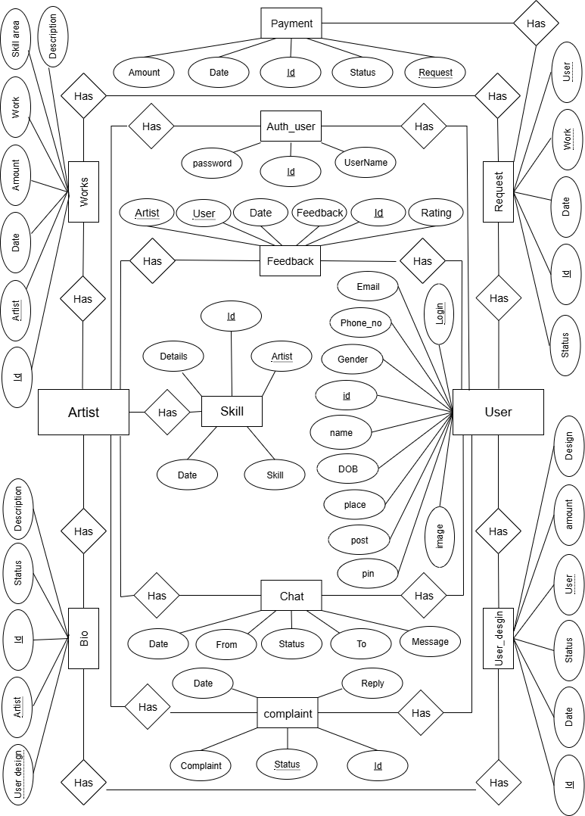

Fig:

